Aim: To study different word embedding for representation of textual data in vectorized form
IDE: Google Colab

Theory:
Word Embedding is an approach for representing words and documents. Word Embedding or Word Vector is a numeric vector input that represents a word in a lower-dimensional space. It allows words with similar meanings to have a similar representation.

Word Embeddings are a method of extracting features out of text so that we can input those features into a machine learning model to work with text data. They try to preserve syntactical and semantic information. The methods such as Bag of Words (BOW), CountVectorizer and TFIDF rely on the word count in a sentence but do not save any syntactical or semantic information. In these algorithms, the size of the vector is the number of elements in the vocabulary. We can get a sparse matrix if most of the elements are zero. Large input vectors will mean a huge number of weights which will result in high computation required for training. Word Embeddings give a solution to these problems.

Need for Word Embedding?
- To reduce dimensionality
- To use a word to predict the words around it.
- Inter-word semantics must be captured.

How are Word Embeddings used?
- They are used as input to machine learning models. Take the words —-> Give their numeric representation —-> Use in training or inference.
- To represent or visualize any underlying patterns of usage in the corpus that was used to train them.

Bag of Words
Bag of Words (BOW) is an algorithm that counts how many times a word appears in a document. Those word counts allow us to compare documents and gauge their similarities for applications like search, document classification, and topic modeling.

Tf-Idf
Tf-Idf is shorthand for term frequency-inverse document frequency. So, two things: term frequency and inverse document frequency. Term frequency (TF) is basically the output of the BoW model. For a specific document, it determines how important a word is by looking at how frequently it appears in the document. Term frequency measures the importance of the word. If a word appears a lot of times, then the word must be important. For example, if our document is “I am a cat lover. I have a cat named Steve. I feed a cat outside my room regularly,” we see that the words with the highest frequency are I, a, and cat. This agrees with our intuition that high term frequency = higher importance.

TF(t) = (Number of times term t appears in a document) / (Total number of terms in the document)

IDF used to calculate the weight of rare words across all documents. The words that occur rarely in the corpus have a high IDF score. However, it is known that certain terms, such as “I”, “a” may appear a lot of times but have little importance. Thus we need to weigh down the frequent terms while scaling up the rare ones

IDF(t) = log_e(Total number of documents / Number of documents with term t in it)

Pre Lab Exercise:
  - Perform BoW vectorization of the corpus
  - Perform TF vectorization of the corpus

Program (Code):

# word embeddings

sentences=[

"India is a diverse and culturally rich country located in South Asia.",

"It is the world’s largest democracy with a population of over 1.4 billion people.",

"Hockey is the national sport of India.",

"Hockey is a popular team sport played with a stick and a ball or puck.",

"It requires speed, teamwork, and good coordination among players.",

"Artificial Intelligence is a technology that enables machines to think and learn like humans.",

"AI is used in applications such as chatbots, self-driving cars, and facial recognition systems."

]

#importing the libraries

import numpy as np

import pandas as pd

from sklearn.feature_extraction.text import CountVectorizer #TF-Bow

from sklearn.feature_extraction.text import TfidfVectorizer #TFIDF

from sklearn.metrics.pairwise import cosine_similarity

#Embeddings using TF-Bow approach

tf_vectorizer=CountVectorizer()

tf_matrix=tf_vectorizer.fit_transform(sentences)

tf_matrix

tf_similarity=cosine_similarity(tf_matrix)

tf_similarity

#Embeddings using TFIDF approach

tfidf_vectorizer=TfidfVectorizer()

tfidf_matrix=tfidf_vectorizer.fit_transform(sentences)

tfidf_matrix

tfidf_similarity=cosine_similarity(tfidf_matrix)

tfidf_similarity

#finding out the document similarity

def doc_sim(similarity_matrix, sentences):

for i in range(len(sentences)):

sims=similarity_matrix[i].copy()

sims[i]=-1

top_index=np.argmax(sims)

print(sentences[i], "-->", sentences[top_index])

doc_sim(tfidf_similarity, sentences)

Results:
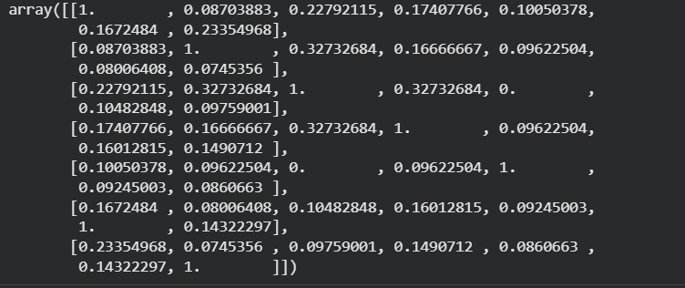
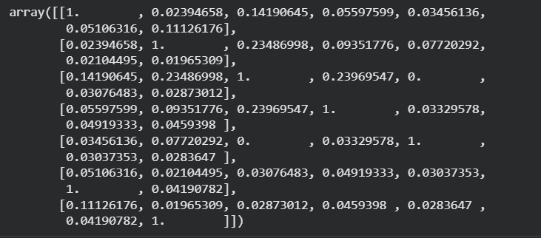

Observation:

• BoW (Bag of Words) converts text into vectors using word frequency. It does not consider meaning of words. Sentences with common words show higher similarity.

• TF Vectorization is similar to BoW as it also depends on word count, so similarity results are almost the same as BoW.

• TF-IDF Vectorization gives importance to meaningful words and reduces weight of common words like is, the, a. It provides more accurate similarity between related sentences.

• Sentences related to India and Hockey show similarity due to common words, while AI-related sentences show similarity with each other.

Post Lab Exercise:
Take three documents and find similarity using
- BoW vectorization
- TF Vectorization
- TF-IDF Vectorization
Comment over the answer obtained in each of the case.
Code:
documents = [
"Deep learning is widely used in image recognition.",
"Neural networks help computers learn complex patterns.",
"Pizza is a popular fast food enjoyed by many people."
]
from sklearn.feature_extraction.text import CountVectorizer, TfidfVectorizer
from sklearn.metrics.pairwise import cosine_similarity

# BoW
bow = CountVectorizer()
bow_matrix = bow.fit_transform(documents)
bow_similarity = cosine_similarity(bow_matrix)

print("BoW Similarity:\n", bow_similarity)

# TF
tf = CountVectorizer()
tf_matrix = tf.fit_transform(documents)
tf_similarity = cosine_similarity(tf_matrix)

print("\nTF Similarity:\n", tf_similarity)

# TF-IDF
tfidf = TfidfVectorizer()
tfidf_matrix = tfidf.fit_transform(documents)
tfidf_similarity = cosine_similarity(tfidf_matrix)

print("\nTF-IDF Similarity:\n", tfidf_similarity)

Output:
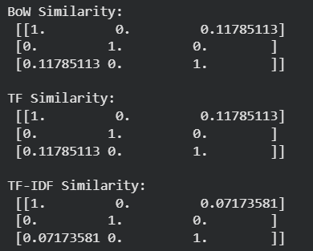
a. BoW Vectorization
Document 1 and Document 2 show higher similarity because both are related to AI topic. Document 3 shows low similarity because it is about food.
b. TF Vectorization
TF gives similar result as BoW because it is also based on word frequency.
c. TF-IDF Vectorization
TF-IDF gives more accurate similarity because it gives importance to meaningful words and ignores common words.

